TEAM4OARS

Input Forms and Output Reports

Version 1.0

Signature Block

COSC 4351 | Name Signature | Date
SE Team Leader
SE SQA
SE Team Leader
SE SQA
SE Team Leader
SE SQA
Example Actor: Guest
1. Search Testimonials: A guest is able to search through testimonials at their leisure. Once entering the site they will be presented with a button they must press to see available testimonials. After pressing the button the guest will see a table full of testimonials sorted by date.

Input Form:

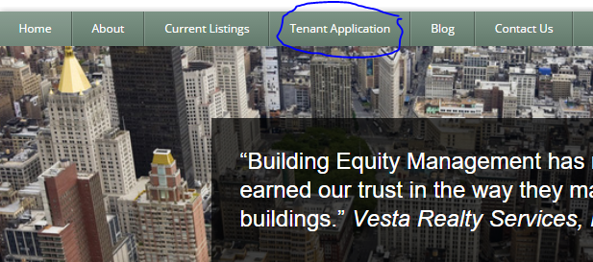

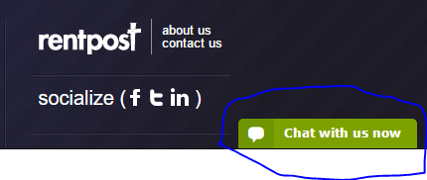

Output Report:

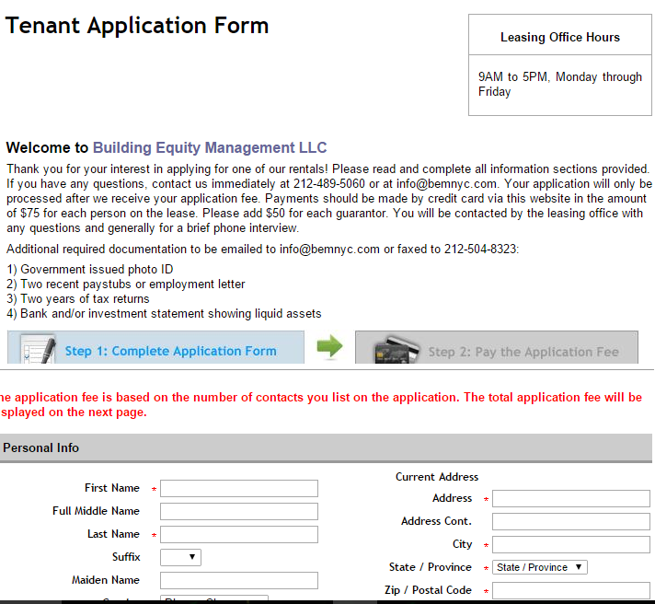
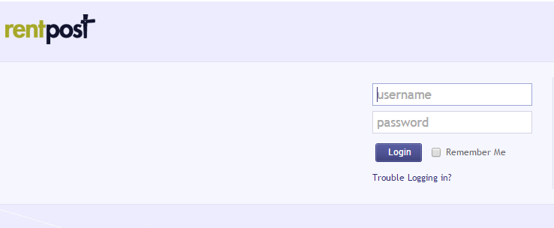

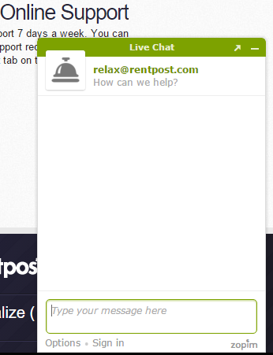

Document Control

Change History

Change History

Table 1: TLs entries (assigned work and due dates) before releasing to the team
Revision | Name | Due Date | Description
1.1 | TM  Joshua Wilburn | 02/06/2016 | While doing Feasibility Study, come up with ideas for the user interface and send ideas
1.1 | TM  Ali Khalid Elsaadi | 02/06/2016 | While doing Feasibility Study, come up with ideas for the user interface and send ideas
1.1 | TM  Devin Bellomy | 02/06/2016 | While doing Feasibility Study, come up with ideas for the user interface and send ideas
1.1 | DBA  Joseph Nguyen | 02/06/2016 | While doing Feasibility Study, come up with ideas for the user interface and send ideas
1.1 | DBA  Stephen Carver | 02/06/2016 | While doing Feasibility Study, come up with ideas for the user interface and send ideas
1.1 | SQA  Benjamin Wightman | 02/12/2016 | While doing Feasibility Study, come up with ideas for the user interface and send ideas.  Review Document
1.1 | TL  Bertol Salgado | 02/06/2016 | While doing Feasibility Study, come up with ideas for the user interface and send ideas

Table 2: Entries when work completed (SVN Commit Comment matches Description)
Revision | Name | Completed Date | Description
1.A | Ali Elsaadi | 2/6/2016 | input and output reports
1.B | TM & Name | XX/XX/XXXX | I …..
1.C | DBA & Name | XX/XX/XXXX | I …..
1.X | SQA & Name | XX/XX/XXXX | I reviewed Document

Table 3: TL entry for RED DELIVERABLES (SVN Commit Comment matches Description)
Revision | Name | Due Date | Description
2.0 | TL & Name | XX/XX/XXXX | I changed Version to 2.0

Document Storage
This file is stored in SVN at https://svn.cs.uh.edu/svn/cosc4351/team4/TEAM PROJECT DELIVERABLES/Input Forms and Output Reports.doc.

